MODERN DATABASE SYSTEMS LAB 10

Student Information System Design using MongoDB Part -1

NAME: PAVITHIRAN.V ROLL NO: 235229122

db.students.insertMany([

{

_id:"arun", name:"arun Kumar", year:1992, courses: ['java', 'php']

},

{

_id:"sam", name:"sam peter", year:1995, courses: ['php', 'python', 'java']}

,

{

_id:"anna", name:"anna eva", year:1997, courses: ['java']

},

{

_id:"rex", name:"rex samuel", year:1988, courses: ['python']

},

{

_id:"olivia", name:"olivia cathy"

}

]);

> db.students.find()

{ "_id" : "arun", "name" : "arun Kumar", "year" : 1992, "course" : [ "java", "php" ] }

{ "_id" : "sam", "name" : "sam peter", "year" : 1995, "course" : [ "php", "python", "java" ] }

{ "_id" : "anna", "name" : "anna eva", "year" : 1997, "course" : [ "java" ] }

{ "_id" : "rex", "name" : "rex samuel", "year" : 1988, "course" : [ "python" ] }

{ "_id" : "olivia", "name" : "olivia cathy" }

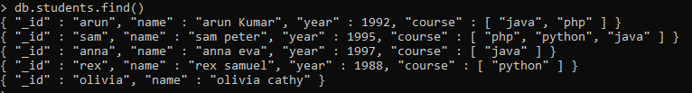

> db.students.find({})

{ "_id" : "arun", "name" : "arun Kumar", "year" : 1992, "course" : [ "java", "php" ] }

{ "_id" : "sam", "name" : "sam peter", "year" : 1995, "course" : [ "php", "python", "java" ] }

{ "_id" : "anna", "name" : "anna eva", "year" : 1997, "course" : [ "java" ] }

{ "_id" : "rex", "name" : "rex samuel", "year" : 1988, "course" : [ "python" ] }

{ "_id" : "olivia", "name" : "olivia cathy" }

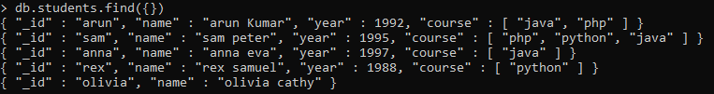

> db.students.find({_id:"arun"})

{ "_id" : "arun", "name" : "arun Kumar", "year" : 1992, "course" : [ "java", "php" ] }



> db.students.find({name:"arun Kumar", year:1992})

{ "_id" : "arun", "name" : "arun Kumar", "year" : 1992, "course" : [ "java", "php" ] }



> db.students.find({year:{$gte:1990, $lte:2000}})

{ "_id" : "arun", "name" : "arun Kumar", "year" : 1992, "course" : [ "java", "php" ] }

{ "_id" : "sam", "name" : "sam peter", "year" : 1995, "course" : [ "php", "python", "java" ] }

{ "_id" : "anna", "name" : "anna eva", "year" : 1997, "course" : [ "java" ] }



> db.students.find({courses:{$exists:true}})

> db.students.find({courses:{$exists:true}})

{ "_id" : "arun", "name" : "arun Kumar", "year" : 1992, "courses" : [ "java", "php" ] }

{ "_id" : "sam", "name" : "sam peter", "year" : 1995, "courses" : [ "php", "python", "java" ] }

{ "_id" : "anna", "name" : "anna eva", "year" : 1997, "courses" : [ "java" ] }

{ "_id" : "rex", "name" : "rex samuel", "year" : 1988, "courses" : [ "python" ] }

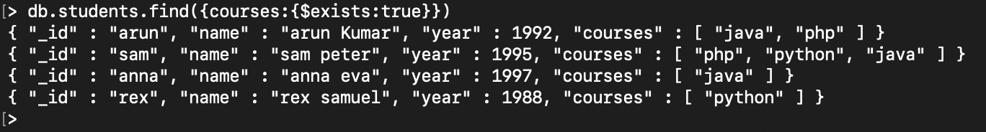

> db.students.find({courses:"php"})



> db.students.find({courses:{$in:["php","oracle"]}});

{ "_id" : "arun", "name" : "arun Kumar", "year" : 1992, "course" : [ "java", "php" ] }

{ "_id" : "sam", "name" : "sam peter", "year" : 1995, "course" : [ "php", "python", "java" ] }



db.students.find({courses:{$all:["php","oracle"]}});



db.students.find({$or:[{year:1992}, {rating:{$gte:3}}]});

> db.students.find({$or:[{year:1992}, {rating:{$gte:3}}]});

{ "_id" : "arun", "name" : "arun Kumar", "year" : 1992, "courses" : [ "java", "php" ] }



db.students.find({}, {name:1, year:1})

> db.students.find({}, {name:1, year:1})

{ "_id" : "arun", "name" : "arun Kumar", "year" : 1992 }

{ "_id" : "sam", "name" : "sam peter", "year" : 1995 }

{ "_id" : "anna", "name" : "anna eva", "year" : 1997 }

{ "_id" : "rex", "name" : "rex samuel", "year" : 1988 }

{ "_id" : "olivia", "name" : "olivia cathy" }

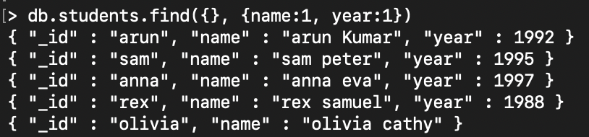

db.students.find({}, {courses: 0, _id:0})

> db.students.find({}, {courses: 0, _id:0})

{ "name" : "arun Kumar", "year" : 1992 }

{ "name" : "sam peter", "year" : 1995 }

{ "name" : "anna eva", "year" : 1997 }

{ "name" : "rex samuel", "year" : 1988 }

{ "name" : "olivia cathy" }

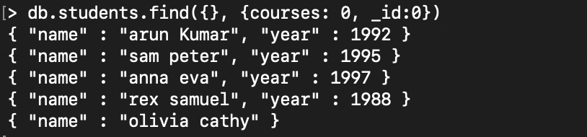

db.students.find({}, {name:1, courses:{$slice:2}, _id:0})

> db.students.find({}, {name:1, courses:{$slice:2}, _id:0})

{ "name" : "arun Kumar", "courses" : [ "java", "php" ] }

{ "name" : "sam peter", "courses" : [ "php", "python" ] }

{ "name" : "anna eva", "courses" : [ "java" ] }

{ "name" : "rex samuel", "courses" : [ "python" ] }

{ "name" : "olivia cathy" }

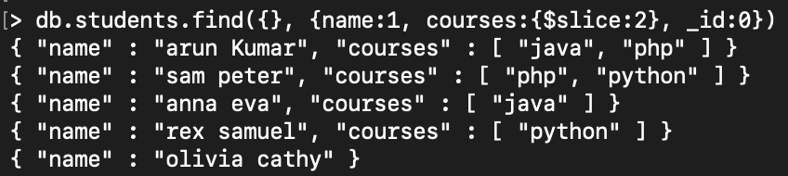

db.students.find().sort({year:1, name:-1})

> db.students.find().sort({year:1, name:-1})

{ "_id" : "olivia", "name" : "olivia cathy" }

{ "_id" : "rex", "name" : "rex samuel", "year" : 1988, "courses" : [ "python" ] }

{ "_id" : "arun", "name" : "arun Kumar", "year" : 1992, "courses" : [ "java", "php" ] }

{ "_id" : "sam", "name" : "sam peter", "year" : 1995, "courses" : [ "php", "python", "java" ] }

{ "_id" : "anna", "name" : "anna eva", "year" : 1997, "courses" : [ "java" ] }

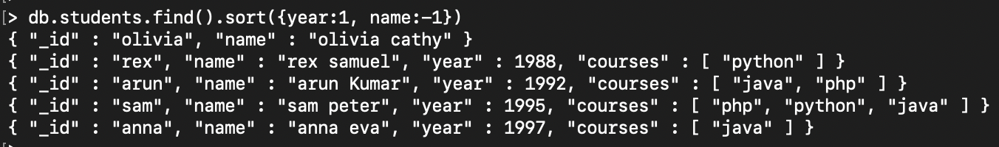

db.students.find().sort({name:1}).skip(1).limit(2)

> db.students.find().sort({name:1}).skip(1).limit(2)

{ "_id" : "arun", "name" : "arun Kumar", "year" : 1992, "courses" : [ "java", "php" ] }

{ "_id" : "olivia", "name" : "olivia cathy" }



db.students.find().sort({name:1}).limit(2).skip(1)

> db.students.find().sort({name:1}).limit(2).skip(1)

{ "_id" : "arun", "name" : "arun Kumar", "year" : 1992, "courses" : [ "java", "php" ] }

{ "_id" : "olivia", "name" : "olivia cathy" }

